中国信通院“全球网测”
https://mp.weixin.qq.com/s/-A4i_XlgygEz5DDmzHKtYg

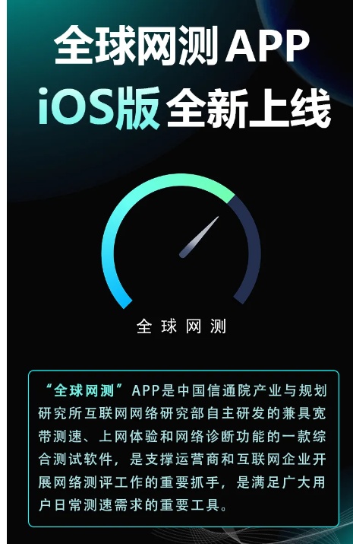

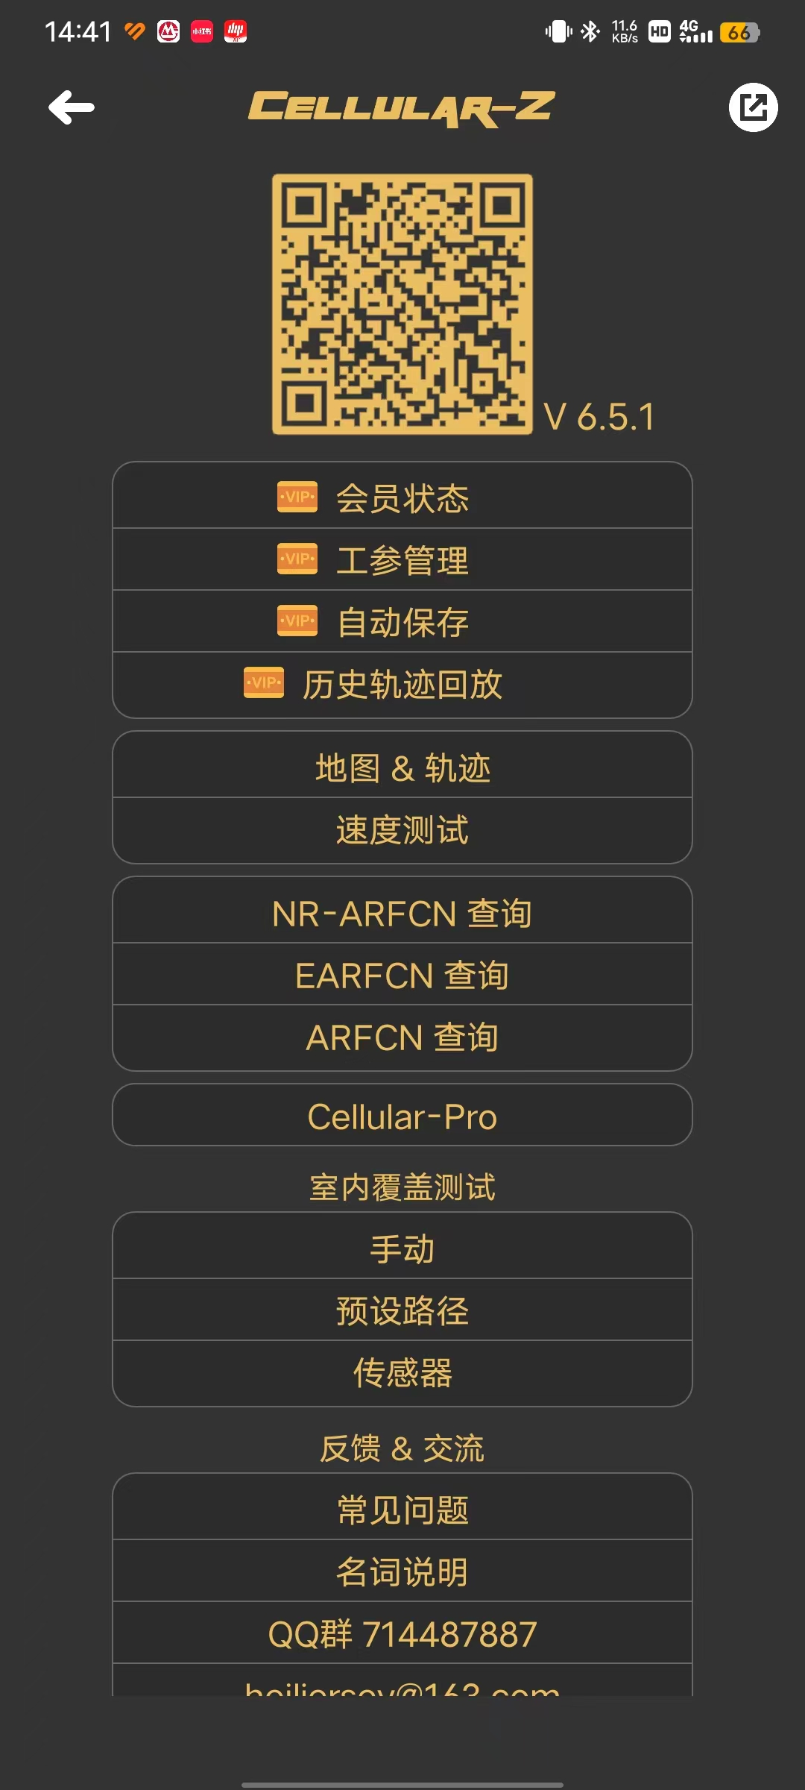
https://mp.weixin.qq.com/s/NFoDEXdiEQp-Rk5TuCkeTg


https://mp.weixin.qq.com/s/FUWgon_deT2GxbZEgXPjEA
https://mp.weixin.qq.com/s/FUWgon_deT2GxbZEgXPjEA

奥维地图，勘查站点，类似谷歌地球

